WEST LONDON WASTE AUTHORITY
Report of the Projects Director and Waste Minimisation Manager | 26th June 2020
Projects and Waste Minimisation Update

SUMMARY
This report provides an update on the Authority’s waste minimisation, efficiency and joint working projects.
RECOMMENDATION(S)
- The Authority is asked to note the information within this report.
- Introduction - The waste programme as detailed in the March Authority paper has six key themes (Appendix 1), initiated by Officers and delivered in conjunction with the constituent Boroughs to develop collaborative working in West London. This report covers the main project updates and governance of the wider programme is managed through the WLWA senior management team.
- Data – This is a long-term strategic project, supporting waste data flow reporting and is aligned with the Resources and Waste Sector Deal, to capture and share up to date waste management data for the West London Boroughs. Officers have designed a data flow model to provide high level information and navigation through the different levels and dashboards (Appendix 2 Data). The system has been designed to increase awareness of and access to the existing data. Officers are working on access for Boroughs to near-live data and dashboards within the next three months.

- Waste Minimisation (MJ) – Officers have shifted focus from attending public events due to the Covid-19 lockdown to managing a range of waste reduction and improvement projects at Abbey Road Household Reuse and Recycling Centre. The improvements are focused on the customer experience and include infrastructure redesign and development, staff training and interacting with site users to gather usage data on HRRC versus kerbside and wider service usage. To capture and interrogate the data the team is asking all site users to complete a questionnaire on residency and waste types. This information is used to heatmap service users and inform on HRRC system usage (Appendix 3 HRRC Survey). The team is also actively monitoring the level of contamination within the waste recyclable waste streams to develop improved segregation systems to be adapted onto other HRRCs. This work has a direct impact on the value and quality of the resources recovered on site.

- HRRCs / Sites – Officers are in the process of reviewing and analysing the provision of HRRCs within the context of the whole waste system in the West London region and working with the Environment Directors on the fortnightly calls. Following the closure of the sites during the Covid-19 lockdown and the subsequent reopening, a number of risks and opportunities have arisen including site capacity.
The HRRCs are a constrained system with limited capacity due to social distancing that has led to queuing at sites. The ongoing restrictions have led officers to investigate alternative solutions to provide the service whilst also delivering carbon, air quality and customer service benefits. These include booking systems and enhanced bulky waste collections from households.
A booking system would ensure that there is sufficient time for residents to effectively segregate materials for recycling whilst on site as well as manage the dispersal of queues more evenly through the day. Officers are looking to implement a booking system for all users of the Abbey Rd site from the 25th June. The data captured from the booking system will be used to inform on usage patterns, kerbside service limitations and trade abuse of resident services.
Officers have identified the opportunity to enhance the bulky waste home collections systems to help alleviate congestion and cut down on resident journeys to the HRRCs. Officers are arranging a pilot scheme to run across the West London specifically aimed at next day collections of material that would have otherwise been driven to the HRRCs. This system reduces traffic movement, reduces carbon, improves the traffic flow on the HRRCs and enhances customer experience with an ‘Uber’ style interface.
Collections – Officers are rolling out fill level sensors into the participating Boroughs with c.500 operational by the end of June. Work on the efficiency of the collections system operating across the sensors is ongoing and this project will be linked with the data project, please see sensors dashboard (Appendix 4).
The food waste project is progressing with most Boroughs completing the Value Stream Mapping of the services with WLWA officers (end June) to establish baseline for the existing services and agree business cases to access the investment. The VSM process will incorporate all of the lessons learnt from the Food Waste Comms project this year.
WLWA officers have used the Borough business cases to identify the potential cross boundary benefits that can be jointly delivered including, procurement, delivery systems and collections routing.
A full analysis and breakdown of the expected Return on Investment from each the business cases will be the basis for the approval of funds and milestone payments.
- Risk – The Covid-19 lockdown has created an increased risk to all projects therefore the full programme is being reviewed to reassess the requirements for delivery given the current restrictions and possible benefits. The impact of the lockdown so far has been minimised through revised working practices and focusing on remote delivery.
There are still further consultations and a revised timetable for legislation is expected, related to the Resources and Waste Strategy, which must be considered during the development of all projects.
- Financial Implications – During the budgeting for the 2020/2021 year there was no requirement for an additional bulky waste service or a booking system at the HRRCs. The delivery of these projects will be unbudgeted in 2020/21. The cost impact is currently unknown but it is expected to be low. The projects overall impact on the whole system is expected to help mitigate some of the costs due to Covid-19.
- Staffing Implications – None
- Health and Safety Implications – The Projects Team has moved predominantly to working from home during the Covid-19 pandemic. All fieldwork has been risk assessed for the tasks to be completed and have had additional Covid-19 controls included in the mitigation measures.
Members of the Waste Minimisation Team have moved to working on the Abbey Rd site during the pandemic and have all had the required inductions to operate on the site including the update for operations during the C19 pandemic.
- Legal Implications - None
- Joint Waste Management Strategy
The projects mentioned in this report are intrinsically linked to the Authority’s Joint Waste Management Strategy. The projects are driving the design of the new policy through data, best practice and identification of opportunities as well as delivering change to meet the desired outcomes and targets in the Strategy.

Contact Officers | Peter Tilston, Projects Director 01895 545510  petertilston@westlondonwaste.gov.uk  Mildred Jeakins, Waste Minimisation Manager 01895 546623  mildredjeakins@westlondonwaste.gov.uk  Emma Beal, Managing Director 01895 545515  emmabeal@westlondonwaste.gov.uk

Appendix 1 Programme Objectives
Data |  |  | Objective 1: To view and share holistic data for the sub region
Waste Minimisation |  |  | Objective 2: To reduce waste and increase recycling
Collections |  |  | Objective 3: Align the collections strategy with the disposal strategy
Sites |  |  | Objective 4: To create a network of sites for recycling and reduce costs
Procurements |  |  | Objective 5: To reduce risk and increase opportunity
Recyclable Processing |  |  | Objective 6: To create recycling sorting capacity to reduce risk and jointly procure processing services
Strategic Partner Projects |  |  | Objective: Increase efficiency of the Transfer Station site and SERC

Appendix 2 Data model and beta dashboards

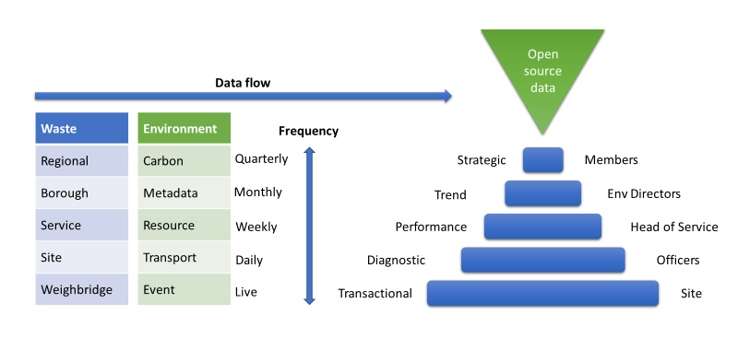

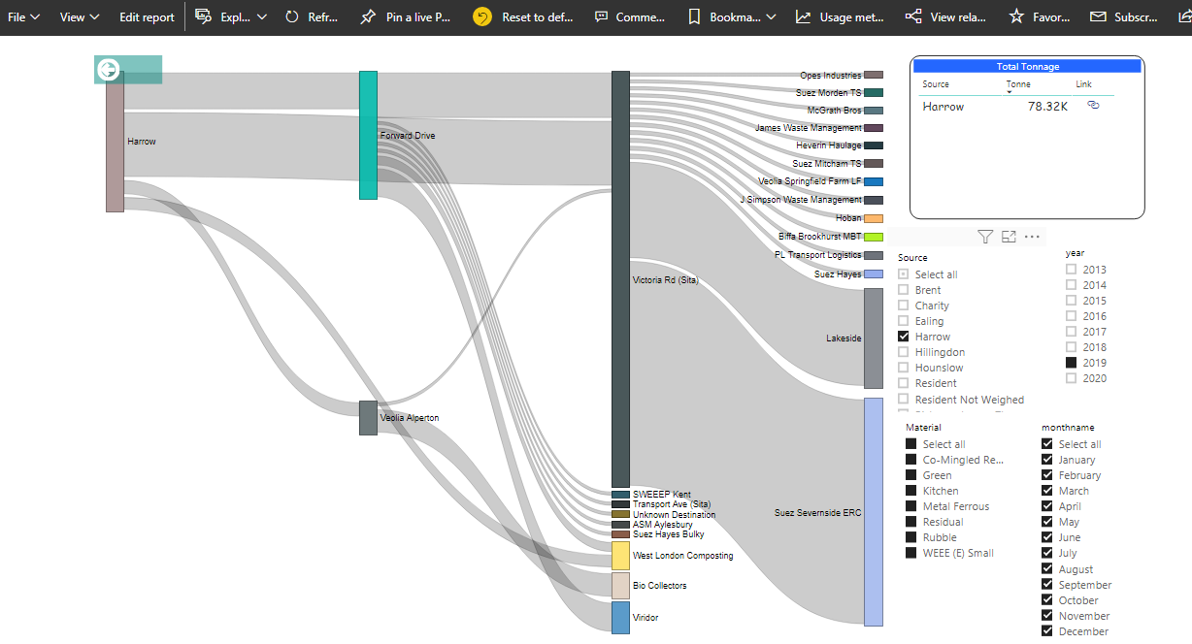
Appendix 3 HRRC user survey paper

Appendix 4 – Sensors dashboard
